
JC2 PRELIMINARY EXAMINATION
TAMPINES MERIDIAN JUNIOR COLLEGE

CANDIDATE
NAME
CIVICS GROUP
_________________________________________________________________________________
H2 GEOGRAPHY 9173/01
Paper 1 12 September 2024 3 Hours

INSERT
___________________________________________________________________________

READ THESE INSTRUCTIONS FIRST

This Insert contains all the Resources referred to in the questions.

_________________________________________________________________________________

This document consists of 6 printed pages and 1 blank page.
Blank Page

Resource 1 for Question 1
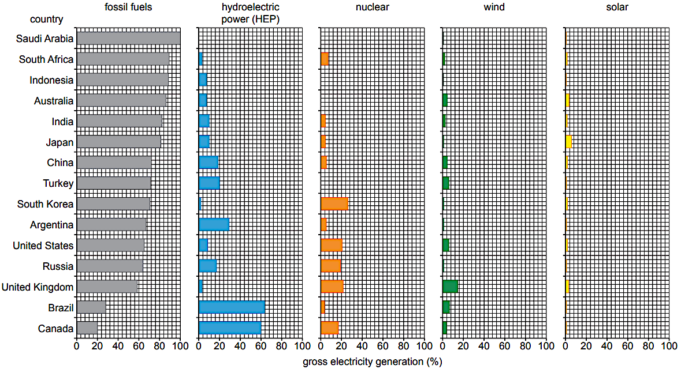
Types of energy resources used for electricity generation in selected countries, 2017

Resource 2 for Question 1
Global distribution of solar power energy plants
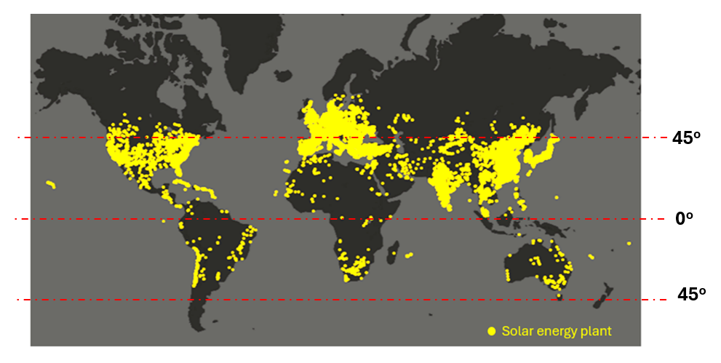

Resource 3 for Question 1
Distribution of employment by sector for Low Income Countries (LICs) and High Income Countries (HICs), 1991 and 2018
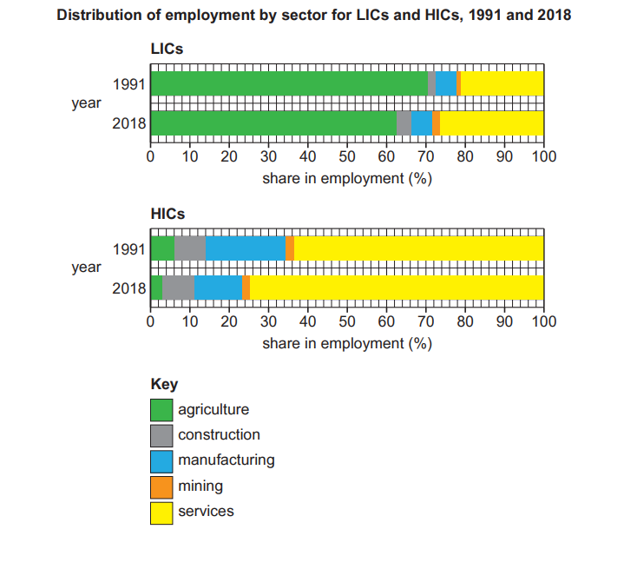

Resource 4 for Question 2
Climographs of two different tropical climates in Southeast Asia
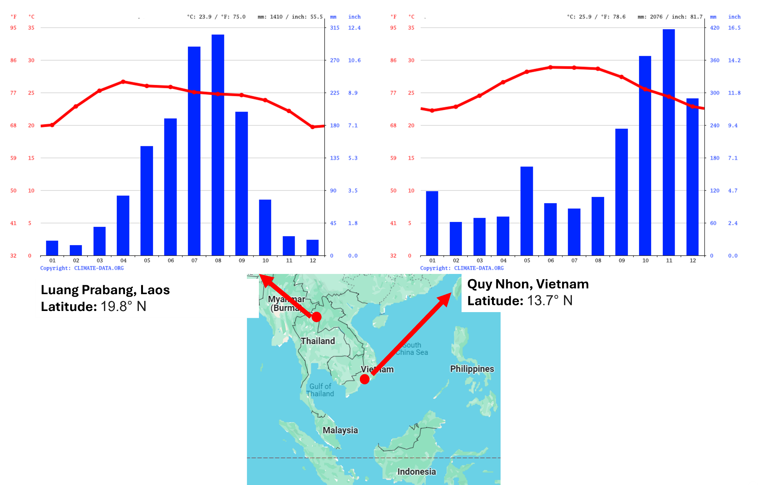

Resource 5 for Question 2
The High Country Rivers, New Zealand
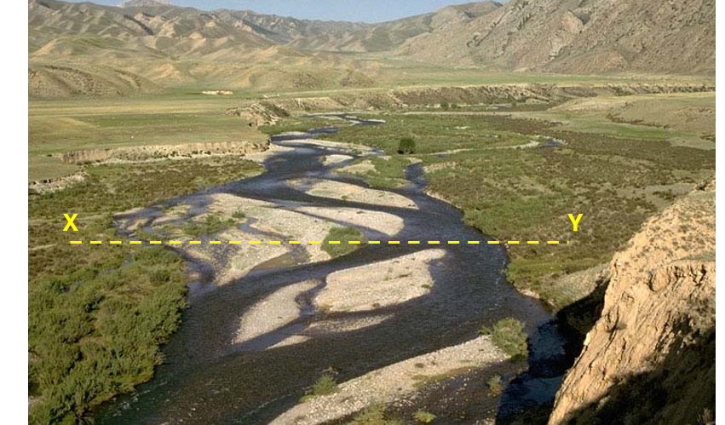

Resource 6 for Question 2
Landslide potential map of mainland USA

